**Observable Trends – PyCitySchools – Bejirose K. Stanly**

**Pandas Challenge**

* Charter schools performed much better in Math, reading, and overall passing compared to District schools.
* Charter school size is smaller than the District schools, and the budget per student for District School is a little less compared to District School, but there is not much variation in budget per student (ranging from $580-$675) in both the school types.
* All five top performing schools are charter schools and all bottom performing schools are District Schools.
* Schools did not perform well with the higher budget, in fact schools underperformed with higher budget. Please see the summary below:

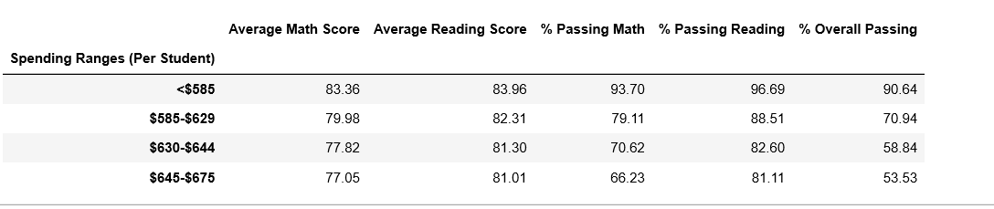

* In my opinion, analyzing the given data, school size might be one of the biggest factors for this performance difference. Please see the summary below. Since small and medium sized school performed almost the same, there might be other reasons as well, such as teachers’ qualifications, teaching practices etc. Larger size schools performed poor compared to small and medium sized schools.

